App Control Stencil Machine ：
- iOS: Search for EZ TATTOO PRINTER in the Apple App Store.
- Android: Scan the QR code to downl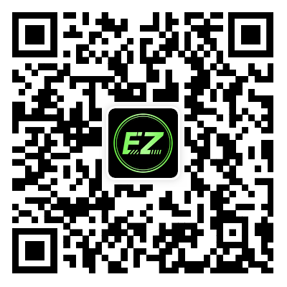
- Windows: Download and install the driver.

Manual click here
EZ Wireless Tattoo Transfer Stencil Printer, a cutting-edge tool designed for professional tattoo artists who demand precision, efficiency, and portability. This innovative device simplifies the stencil creation process, ensuring flawless results every time.
- High-Resolution Printing: Equipped with advanced thermal printing technology, the EZ printer delivers crisp and detailed stencils at 203 DPI. Perfect for intricate designs, it ensures that every line and detail is accurately reproduced.
- Wireless Connectivity: The printer supports both Bluetooth and USB connections, making it compatible with Android, iOS, Windows, and Mac systems. Seamlessly transfer and print your designs from virtually any device.
- Compact and Lightweight Design: This printer is highly portable. Ideal for use in studios, conventions, or on-the-go tattoo sessions.
- Efficient Battery Life: Powered by a robust 2500mAh battery, the EZ printer provides reliable performance throughout extended tattooing sessions without frequent recharging.
- Versatile Paper Compatibility: Designed to work with A4 tattoo transfer paper, it accommodates various stencil sizes to suit diverse tattoo projects.
Feature | Details
Printing Width | 210mm
Paper Size | A4 Transfer Paper
Connection Method | USB + Bluetooth
Resolution | 203 DPI
Size | 315 x 76 x 53 mm
Battery Capacity | 2500mAh
Power Input | 5V --- 2A
Supported Systems | Android, iOS, Windows
Why Choose EZ Wireless Tattoo Transfer Printer?
- Precision and Quality: The high-resolution printing ensures that even the most complex designs are transferred flawlessly onto stencil paper.
- Time-Saving Efficiency: Rapid printing capabilities allow artists to focus more on their craft rather than stencil preparation.
- Mess-Free Operation: Utilizing thermal printing technology eliminates the need for ink or toner, keeping your workspace clean.
- Universal Compatibility: Whether you prefer Android, iOS, Windows, or Mac devices, this printer integrates effortlessly into your workflow.

